Sample mobility concepts for SMEs

Notes
SBB is committed to helping companies implement state-of-the-art mobility management. Our aim is to provide you with the best possible support in all mobility matters and thereby increase the economic, ecological and social sustainability of your corporate mobility. In addition to a portfolio of mobility services spanning all modes of transport (public transport, motorised private transport and human-powered mobility), we have a solid network of partners in the field of mobility and transport planning.
We also provide a mobility check that you can complete at business.sbb.ch. The check is designed for small and medium-sized enterprises (SMEs) that are interested in analysing commuting and business mobility at their company location. The results of the check include the following:
- Modal split for commuting and business mobility
- Estimate of the public transport quality class at your location
- CO₂‑reduction path based on the information you provide
Along with the analysis results, you will receive specific recommendations for action that you can implement and integrate directly into your mobility concept.
This document is a sample mobility concept and is intended solely as an example and source of inspiration for SMEs in Switzerland that wish to create their own mobility concept.
Disclaimer:
SBB accepts no responsibility or liability for the contents, recommendations or consequences of implementing this sample document. The document is not a substitute for consultation with accredited mobility consultants and makes no claim to completeness or legal validity. If you have specific questions or legal uncertainties, please seek specialist support.

Framework and organisational structure
Describe the framework and organisational structure for creating the mobility concept.
- SAMPLE PERSON is the project manager for the mobility concept and the contact person for external partners.

- The decision-making body consists of various stakeholders (Management Board, Human Resources, Facility Management) whose tasks are set out in the organisational chart.
- Optional: A working group made up of employees, external partners and affected users provides support with development and implementation.
- Etc.

Analysis of the initial situation
The overall mobility model shows the three forms of mobility that directly concern the company: business mobility, commuting and customer mobility.
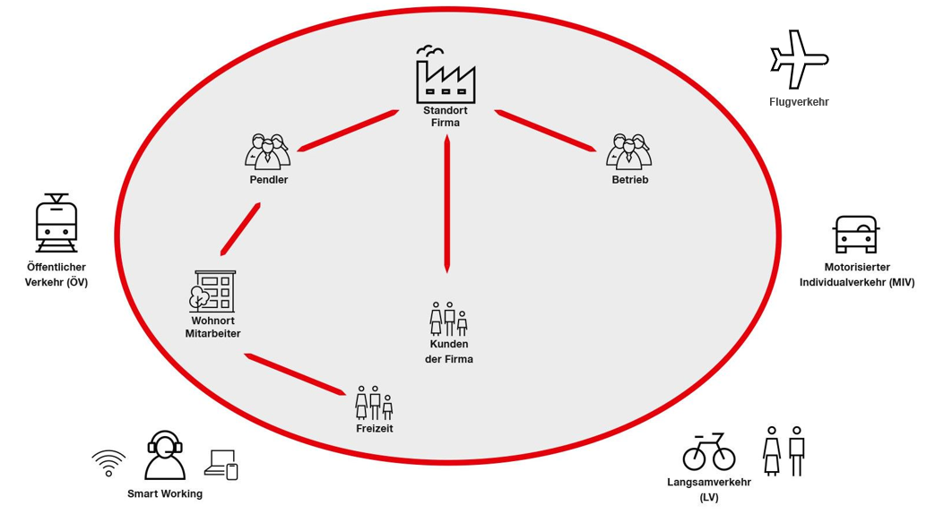
Provide general information about the company (number of employees, travel).
SAMPLE COMPANY employs around 150 people at its location in SAMPLE LOCATION. Travel at SAMPLE COMPANY is generally limited to domestic destinations. Occasionally, there may be 10 to 20 flights per year.
Etc.

  - Location and current public transport services
    - Accessibility by public transport and public transport services
Describe how easy it is to reach the location using public transport. Consult the SBB timetable www.sbb.ch to do this. Describe any fringe benefits currently offered in this area.
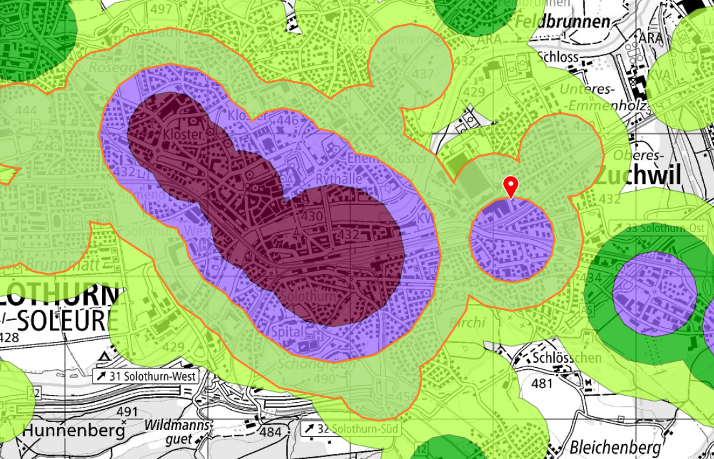
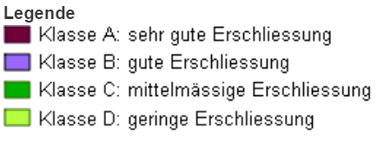
Source: www.are.admin.ch/en / Web GIS map
Switzerland’s Federal Office for Spatial Development (ARE) has given the Grubenstrasse location a public transport quality class of B (= good accessibility). Note: The mobility check on the business.sbb.ch website automatically rates the accessibility of the location when you enter the postal code.
The SAMPLE COMPANY headquarters at SAMPLE ADDRESS can be reached via the SAMPLE LOCATION S-Bahn station, with trains running approximately every ten minutes. From the station, it is only a few minutes’ walk. The S-Bahn operates on weekdays from 5:30 to 00:15.
No fringe benefits are currently offered in the area of mobility (public transport).
Etc.

    - Accessibility by motorised private transport and parking spaces
Describe how easy it is to reach the location by car or motorbike and calculate the current subsidy for parking space users.
Motorway exit XXX is 1.6 km away. The route to SAMPLE STREET is very prone to traffic jams and very difficult to drive on during rush hour.
Many employees live out of town and drive to work. The number of parking spaces is limited and there is a waiting list that works on a first-come, first served basis.
Location | Number of parking spaces | Accessibility by public transport | Parking fees  (internal)/  month [CHF) | Parking fees  (external)/  month [CHF]
Sample Street 1 | 50 | Good | 25 | 125
Sample Street 2 (car park) | 40 | Good | 50 | 150
This means that the parking space subsidy (the difference between the price paid by employees and the market value) for employees who drive their car to work (motorised private transport) amounts to around CHF 1,200 per year.
Etc.
    - Accessibility by human-powered mobility and bicycle parking spaces
Describe how easy it is to reach the location by bicycle and the available cycling infrastructure.
At company headquarters, employees have access to bicycle racks with space for approximately 20 bicycles. The bicycle parking spaces are covered but not completely enclosed. There is only one shower. There is currently no charging infrastructure for e-bikes.
Etc.
    - Vehicle fleet
Outline the structure of your company’s fleet here.
Company cars for SAMPLE COMPANY: 27 company cars, of which 5 are pool cars. Of the 27 company cars, 5 are provided as a benefit to members of the Management Board.
Etc.

  - Mobile and flexible working (working from home) as an influencing factor
Describe the rules for working from home and for mobile and flexible working.
Employees who meet the criteria for working from home have the option to do so for up to 20% of their working hours on a regular basis. The employees are free to decide whether they wish to work from home.
Etc.
  - Conclusion
Summarise your conclusions regarding the initial situation.
Public transport   | The SAMPLE COMPANY headquarters can be accessed easily using public transport. Even commuters who travel longer distances by public transport can get to work relatively easily and efficiently.
Motorised private transport   | Driving through the city is particularly difficult during rush hour (due to traffic jams). In addition, the number of parking spaces is often insufficient.
Human-powered mobility   | The SAMPLE COMPANY headquarters can be reached very easily on foot, especially in combination with public transport.
Work Smart   | A certain proportion of employees are permitted to work from home for a maximum of 20% of their working hours.

  - Mobility behaviour
Describe the current mobility behaviour of employees. The analysis results from the mobility check (LINK) can help you with this.
In 20XX, a survey on mobility behaviour was carried out in which employees were asked about their commuting habits and their level of satisfaction. The survey showed that around 6 out of 10 employees (59%) used motorised private transport to get to work. A high proportion of trainees and young employees preferred to use public transport.
Etc.
ÖV = public transport, MIV = motorised private transport, LV = human-powered mobility
  - Challenges
Describe the mobility challenges in your company.
- Limited parking available at headquarters – not enough parking spaces
- Unequal treatment of commuters – currently, only commuters who use motorised private transport receive financial support
- Achieving net zero greenhouse gas emissions by 2040 at the latest (company’s own target)
- Etc.

Objectives of the mobility concept
Describe the objectives of the concept.
- Reduce the proportion of commuters using motorised private transport by at least 10% within two years.
- Actively encourage employees to use public transport and bicycles.
- Increase our appeal as a sustainable employer.
- Actively contribute to reducing CO₂ emissions and comply with legal requirements (net zero by 2050, company’s own target date is 2040).
- Reduce parking space requirements by changing behaviour.
- Etc.

Catalogue of measures (options)
Select specific measures from the following catalogue that will support you in achieving your objectives.
  - Commuter mobility
Contribute towards the cost of annual public transport travelcards:
Do you want to promote public transport? Allow your employees to enjoy sustainable mobility by giving them a coupon or digital voucher towards the cost of an annual public transport travelcard.
Company travelcard for a fare network:
Do you want to promote public transport? A company travelcard is an annual travelcard that is discounted for employees thanks to financial contributions from their employer and the fare network. The discount applies not only to annual company travelcards but also to GA Travelcards, Point-to-Point Travelcards and Modular Travelcards.
Mobility budget: Do you want to promote sustainable and intermodal mobility? Combine a public transport travelcard with other transport and mobility options of your choice. This gives you flexible travel options and means you are doing your bit for the environment.
GA Travelcard for Trainees:
Do you want to present yourself as an attractive employer, especially to young people? The GA Travelcard for Trainees offers your apprentices full mobility, with unlimited travel on SBB routes and on most private railways across Switzerland. The GA Travelcard is also valid on Postbuses, boats and local public transport services such as trams and buses in most cities and urban areas.
Bike to Work: Do you want to promote green mobility or reduce the number of car parking spaces? “Bike to Work” is a national Swiss campaign to promote health in companies by encouraging thousands of commuters get on their bikes and cycle to work in May and June every year. Numerous companies use “Bike to Work” as an opportunity to boost team spirit and improve employee fitness while demonstrating their commitment to sustainable mobility.
Carpooling: Do you want to be more eco-friendly and reduce the number of parking spaces you need? Then encourage your employees to carpool.
Parking space analysis: Do you have a parking space problem? An in-depth analysis of your parking situation (motorised private transport and human-powered mobility), including the possibility of implementing a parking space management system.
Human-powered mobility and bicycle parking spaces
Do you want to promote human-powered mobility? Assessment of your company’s appeal with regard to human-powered mobility and development of suggestions for improvement.
Fringe benefits: Do you want to use fringe benefits to influence mobility behaviour? Fringe benefits or internal bonus programmes are an effective tool for managing commuting behaviour. Solutions for optimisation are developed and discussed jointly in an in-depth review of the benefits you provide.

  - Business mobility
SBB Businesstravel: Do you want to promote public transport? Do you want to purchase your tickets conveniently online or via your smartphone, or manage your employees’ travel activities with ease? Or perhaps you would like a personal consultation? No problem – as a business customer, you have various service channels available to you through SBB Businesstravel.
Mobility Carsharing: Do you want to reduce mobility costs? A business subscription gives you access to all Mobility vehicles (from electric cars to transporters) at all Mobility locations at a reduced rate. Everything is included in the rates, so you don’t need to worry about a thing.
Combined mobility: Do you want to promote combined mobility with public transport? Examine the Park+Rail option. Bike+Rail: Cover the first/last mile by bicycle and save time and money. “Rent company bicycle parking spaces at railway stations” (for the last mile) in cooperation with SBB Real Estate as a possible project.
Calculate potential savings:
Do you want to reduce economic costs and environmental impact? If your employees switch from cars to public transport and you cover their public transport travelcards instead of their mileage, you can expect your company’s travel costs to be up to five times lower. Use the SBB comparison calculator to find out right away how much your company could save in terms of travel costs, productivity and CO₂ offsetting.

  - Mobility in general
Employee survey: Would you like to analyse your ACTUAL commuting situation and ACTUAL business mobility? The employee survey gives you an overview of your employees’ mobility. How do your employees currently get to work? Are the current possibilities being utilised? What feedback would your employees like to give you regarding mobility?
Emissions report: Are you pursuing specific emission/energy targets? Legal requirement for net zero by 2050. Use SBB’s annual emissions report to document the sustainability of your corporate mobility. The report shows the savings achieved by using public transport.
E-bike sharing: Are you faced with a last mile challenge? Or do employees often have to cover short distances? Renting high-quality e-bikes from Swiss manufacturers on a monthly basis is a smart and sustainable mobility option for your employees. Use e-bikes to help your employees get around during the working day or as a fringe benefit. You can also integrate local bicycle rental systems into your measures.

Mobile and flexible working:
Do you want to promote mobile and flexible working? Travel time spent working can be counted as working time, subject to discussion with the relevant supervisor. The proportion of work carried out from home will be increased to minimise the company’s carbon footprint and improve work-life balance.
ÖV-Live: Do you want to enhance the visibility of public transport? “When is the next bus?” ÖV-Live provides real-time timetable information for all stops in Central Switzerland. You can display this real-time information on your customer information system or separate monitors. ÖV-Live is available for all systems with an internet connection.
MoveSmart: Do you want to set an example for sustainable corporate mobility? The MoveSmart initiative aims to promote companies’ efforts towards sustainable and socially responsible mobility by awarding them a label. A three-level model with specific criteria for sustainable commuting and business travel mobility provides companies with a structure and support to implement measures effectively.
Regional programmes: Are any regional programmes in place? Utilise regional support programmes, if available.
Mobility management: Do you want to make mobility a permanent focus within your organisation? By appointing a mobility officer and embedding the role in your company’s organisation, you make the workforce aware of the issue. The mobility officer is in charge of implementing and monitoring the planned mobility measures. They are also the main contact person for internal and external mobility matters.
Expenses and travel regulations:
Define your travel guidelines with a view to sustainable mobility here. See sample expenses regulations on our website

Implementation of the measures
Describe the implementation of the agreed measures. This is illustrated below using the example of SAMPLE COMPANY.
- We give all trainees a GA Travelcard for public transport.
- We are signing up for the MoveSmart label and aim to achieve Level I within two years.
- Employees receive an annual subsidy for public transport travelcards or Half Fare Travelcards (CHF 800) in the form of coupons.
- Parking spaces are allocated subject to a fee in line with market prices and according to transparent criteria.
- Employees who voluntarily forgo a parking space receive an additional bonus.
- We promote cycling by:
  - expanding bicycle parking facilities and E-bike charging stations.
  - providing shower facilities.
  - participating in the “Bike to Work” campaign.
- We keep employees informed and motivated by means of internal communications, campaigns and competitions.
- We are replacing the company cars provided as benefits to members of the Management Board with a multimodal mobility budget that can be used for different modes of transport.
- An annual budget of around CHF 100,000 has been earmarked for implementation.
- Etc.

Monitoring and reviewing the results
Describe how results are monitored and reviewed.
- We conduct an annual survey for the purpose of evaluating the modal split and parking space utilisation.
- We monitor participation in public transport and cycling programmes and employee satisfaction on a regular basis.
- If we fail to meet an objective, we adapt individual measures accordingly.
- Etc.

Organisation of implementation
Describe the roles responsible for implementing the concept.
- Our mobility manager is responsible for ongoing coordination and implementation.
- The decision-making body supervises implementation, prioritisation and budget.
- The tasks and responsibilities are shown in the organisational chart.
- Etc.

